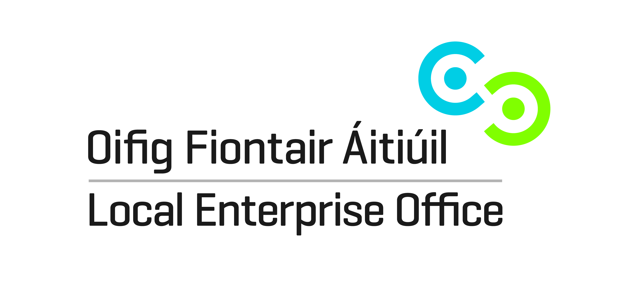
2015 Local Enterprise Office
County Enterprise Awards Application Form (Strictly Confidential)
Typed & Emailed to info@leo.offalycoco.ie
Be sure to add “Enterprise Awards” in the subject line of your email.

GENERAL INFORMATION

Name of Applicant: __________________________________________
Address: __________________________________________
Legal Status: (Tick one) Sole Trader ◻ Partnership ◻ Limited Company ◻
Date of Commencement of Business: _________________________ ______
Phone. : _______________________ Business ______________________ (Mob)
Website : _____________________ email:____________________________

Publicity
All qualifying finalists will be featured in various media publications. To facilitate this, please give a brief description (less than 75 words) of your business, outlining products/services, business history and achievements.

Business Information
What product or service do you supply?

Describe your own background and why you set up in business?

What do you see as the key strengths of your business?

In what way and when, did your Local Enterprise Office/County or City Enterprise Board help you? (Please include the year, type and level of support)

Has this business been grant aided by any other government agency such as Enterprise Ireland, An Bord Bia, Leader Partnership, Inter Trade etc . (If so give details i.e. Agency, Year, Grant Amount, Type etc)

Marketing Your Business
Describe what is different or innovative about your product or service?
Is your customer base local, regional, national, international? Please give details.

How do you market your business?

Are there potential new markets for your business and how do you plan to take advantage of these opportunities?

Technology
How do you use technology in your business?

The Future of your Business
What long-term plans do you have for your business and how do you see it growing and developing over the next 3 years?

What do you see as the key threats/weaknesses to your business? How do you propose to address them?

Employment Details
 | 31/12/2013* | 31/12/2014* | 2015 (current) | Projected 2016
Full Time
Part Time

* Please note employment figures must be as at 31st December of the relevant year - as per those provided for the yearly CEB Employment Survey

Financial Details
Business Growth | 2013 | 2014 | 2015  ( if available)
Annual Sales
Net Profit

Investment | 2013 | 2014 | 2015
Own Funds
Loans
Grants
TOTAL

(Please return your completed application form, together with a current Business Plan and financial statements to your local Enterprise Office by Thursday, 27 August 2015.

Signed: _________________________________

Date: ____________________________________

Offaly County Council, Aras an Chontae, Charleville Road, Tullamore
Tel: 057 93 57480, Fax: 057 93 46868
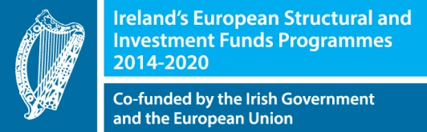

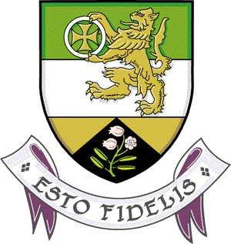
info@leo.offalycoco.ie; www.localenterprise.ie/offaly

